Name: _____________________________________________ Phase Diagram Practice

Instructions: Use the phase diagram for water to identify the state of matter for the temperature and pressure points below.

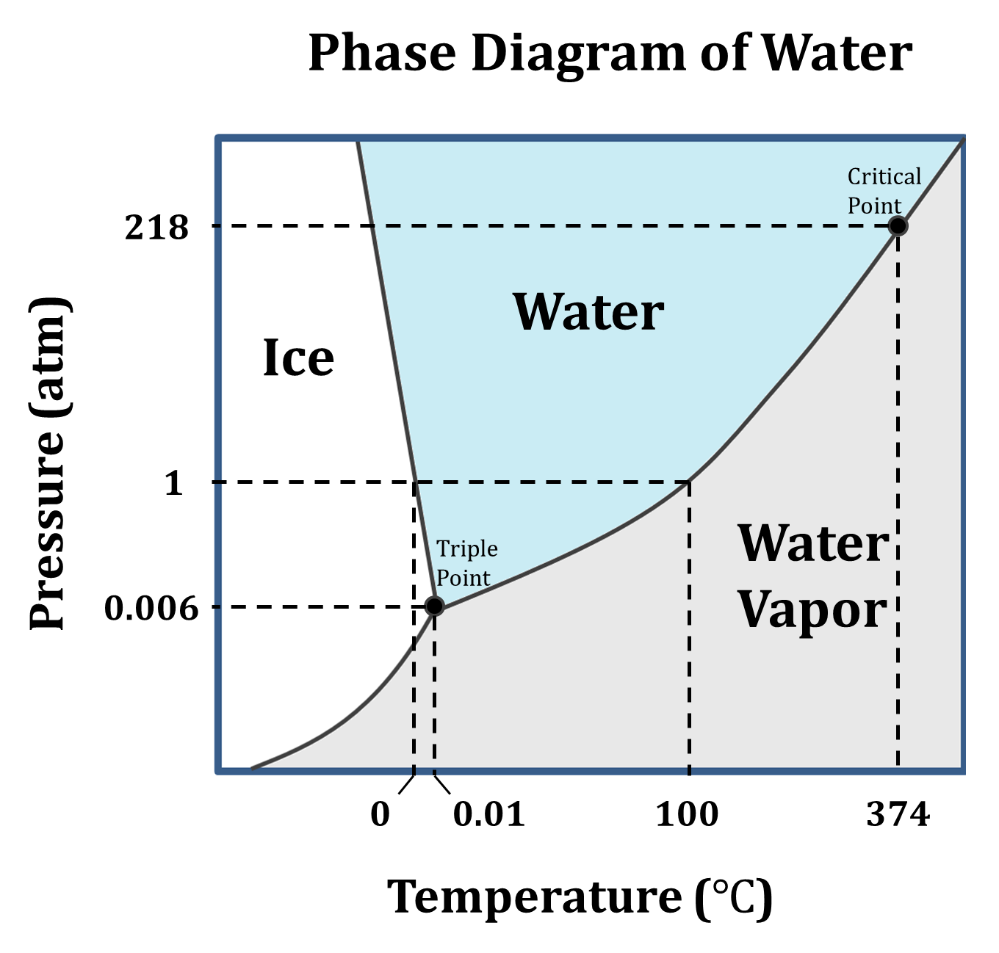

- Temperature 100$℃$; Pressure 1 atm
State of matter: _____________________________________

- Temperature 50$℃$; Pressure 0.006 atm
State of matter: _____________________________________

- Temperature 374$℃$; Pressure 218 atm
State of matter: _____________________________________

- Temperature 0.01$℃$; Pressure 0.006 atm
State of matter: _____________________________________

- Temperature 200$℃$; Pressure 0.005 atm
State of matter: _____________________________________

- Temperature 0$℃$; Pressure 1 atm
State of matter: _____________________________________

- Temperature 374$℃$; Pressure 1 atm
State of matter: _____________________________________

- Temperature 100$℃$; Pressure 100 atm
State of matter: _____________________________________

- Temperature 100$℃$; Pressure 218 atm
State of matter: _____________________________________

- Come up with your own temperature and pressure point and identify the state of matter that the water will be in at that point based on the phase diagram.

- Why are phase diagrams useful to scientists?

- How do you see or use water in each of its three states throughout a day?

