Name: _____________________________________________ Chemical Equations

Instructions: For the chemical reactions below, you must do the following:
- Circle the reactants
- Underline the products
- Draw and label a picture of the elements and compounds in the reaction
- Identify how many of each element are on the product side
- Identify how many of each element are on the reactant side

Example:
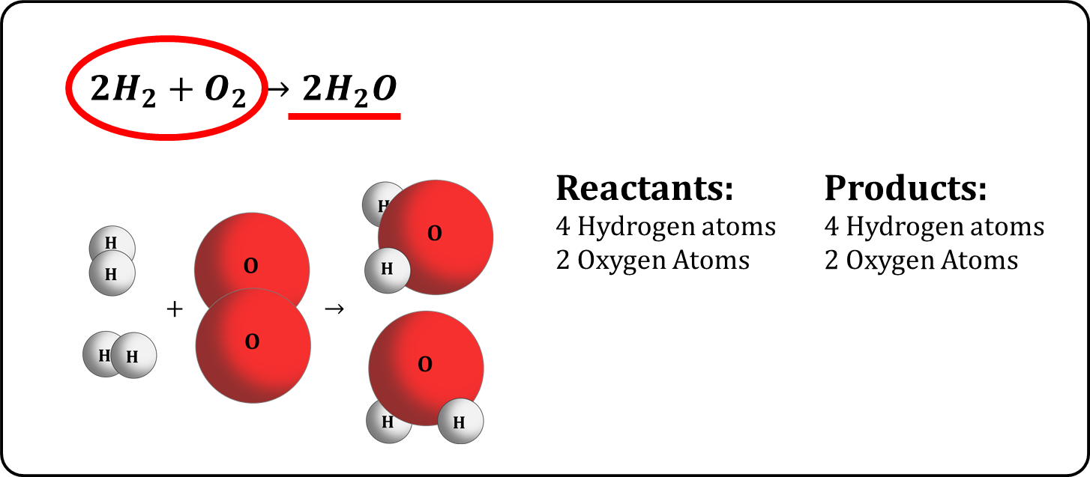

O
O
O

O
O

- $Na+Cl→NaCl$

- $HCl+NaOH→NaCl+H_{2}O$

- $2Na+2H_{2}O→2NaOH+H_{2}$

- $CH_{4}+2O_{2}→CO_{2}+2H_{2}O$

- $8Fe+S_{8}→8FeS$

- $Mg+2H_{2}O→Mg{(OH)}_{2}+H_{2}$

- $Pb{(NO_{3})}_{2}+2KI→PbI_{2}+2KNO_{3}$

Analysis:
- How do chemical equations support the law of conservation of mass?

- What differentiates chemical changes from physical changes?

